An Internship Report
Of
ARTIFICIAL INTELLIGENCE
Submitted
To
School of Computer Science and Engineering
IILM University, Greater Noida, U.P.
In partial fulfilment of the requirement of degree of
B-Tech (CSE)
By
Roll Number of Student: 25SCS1003004399
Name of Student: KAMAL NEGI
Batch: 2026-27
Section: 2CSE2
Internship Organization: Codec Technologies Pvt. Ltd.
Internship Period: 10/07/2026 – 10/08/2026

CANDIDATE'S DECLARATION
I, KAMAL NEGI, hereby declare that the internship report titled “Artificial Intelligence Internship” has been prepared by me as part of the academic requirements of the Bachelor of Technology in Computer Science and Engineering. The report presents the internship information available from my internship completion certificate and a structured academic account of the Artificial Intelligence domain covered by the internship. I affirm that the report has been prepared for academic submission and that the information represented as certificate-specific has been taken from the issued certificate.
Student Name: KAMAL NEGI
Roll No.: 25SCS1003004399

ACKNOWLEDGEMENT
I take this opportunity to express my sincere gratitude to everyone who supported and encouraged me during my internship. The internship provided me with an opportunity to understand the practical relevance of Artificial Intelligence and to connect academic concepts with an industry-oriented learning environment.
I am thankful to Codec Technologies Pvt. Ltd. for providing me the opportunity to complete the one-month internship as an Artificial Intelligence Intern. The completion certificate records the internship period from 10/07/2026 to 10/08/2026 and recognizes the completion of the internship program.
I also express my gratitude to IILM University, Greater Noida, and the School of Computer Science and Engineering for their academic guidance and support. Finally, I thank my family, teachers, and everyone who encouraged me throughout this learning experience.
Student Name: KAMAL NEGI
Roll No.: 25SCS1003004399

TABLE OF CONTENTS
1. Candidate's Declaration i
2. Acknowledgement ii
3. Internship Completion Certificate -
4. Internship Report 1
4.1 Introduction 1
4.2 Organization and Internship Profile 2
4.3 Problem Statement 3
4.4 Internship Objectives 3
4.5 Scope of the Internship 4
4.6 Artificial Intelligence Concepts and Tools 4
4.7 AI System Architecture 5
4.8 Methodology 6
4.9 Learning Outcomes 7
4.10 Certificate and Internship Evidence 8
5. Bibliography/References 9

3. INTERNSHIP COMPLETION CERTIFICATE
The internship completion certificate issued to the student is reproduced below.
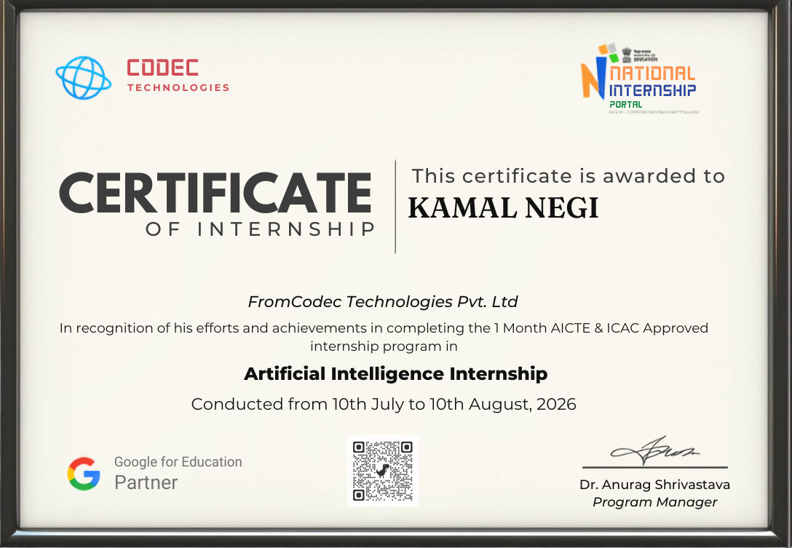

4. INTERNSHIP REPORT

4.1 Introduction
This report presents an academic account of the one-month Artificial Intelligence internship completed by KAMAL NEGI at Codec Technologies Pvt. Ltd. The internship was conducted from 10 July 2026 to 10 August 2026, as stated on the internship completion certificate. The certificate identifies the role as “Artificial Intelligence Intern” and states that the program was AICTE & ICAC approved.
Artificial Intelligence is a major area of Computer Science concerned with developing systems that can perform tasks involving learning, reasoning, prediction, classification, language processing, and decision support. An internship in this domain provides an opportunity to relate classroom concepts with practical workflows and industry expectations.
The detailed weekly curriculum, project title, tools actually used, and individual assignments are not specified on the certificate itself. Therefore, this report keeps certificate-specific facts separate from general academic discussion of Artificial Intelligence.

4.2 Organization and Internship Profile
According to the internship completion certificate, the internship was completed at Codec Technologies Pvt. Ltd. The certificate recognizes KAMAL NEGI as an Artificial Intelligence Intern and records the internship period as 10/07/2026 to 10/08/2026.
The certificate also states that the internship program was AICTE & ICAC approved. No further organizational profile, office location, department structure, project details, or training curriculum is provided on the certificate. Such information should be added only from official organizational material or the internship training documents if available.
Internship details are summarized below:
Particular | Details
Student | Kamal Negi
Organization | Codec Technologies Pvt. Ltd.
Role | Artificial Intelligence Intern
Duration | 1 Month
Start Date | 10 July 2026
End Date | 10 August 2026
Approval stated on certificate | AICTE & ICAC Approved

4.3 Problem Statement
Academic study of Artificial Intelligence often emphasizes algorithms, programming concepts, mathematical foundations, and model behaviour. An internship provides an additional environment in which these concepts can be viewed from a practical and application-oriented perspective. The central learning problem addressed by an AI internship is therefore to understand how AI concepts are translated into structured workflows, evaluated for usefulness, and communicated as practical solutions.

4.4 Internship Objectives
- To understand fundamental concepts and applications of Artificial Intelligence.
- To strengthen practical understanding of AI-related programming and computational thinking.
- To understand the basic workflow of an AI solution, from problem definition and data preparation to model evaluation.
- To develop familiarity with responsible and ethical considerations in AI systems.
- To improve problem-solving, documentation, communication, and professional skills through internship-based learning.
- To connect academic knowledge from B-Tech CSE coursework with an industry-oriented Artificial Intelligence environment.

4.5 Scope of the Internship
The scope of this report is centered on Artificial Intelligence as the internship domain and on the certificate-confirmed internship experience at Codec Technologies Pvt. Ltd. The report discusses the typical stages of an AI workflow, including problem definition, data preparation, model development, evaluation, and application. It also considers responsible AI practices such as privacy, fairness, transparency, and appropriate use of data.
The certificate does not identify a specific capstone project, dataset, model, programming framework, cloud platform, or software stack. Consequently, no particular tool is presented here as a tool that was definitely used during the internship.

4.6 Artificial Intelligence Concepts and Tools
The following concepts are relevant to an Artificial Intelligence internship and provide a useful academic framework for understanding the domain:
- Python programming and computational problem solving.
- Data collection, cleaning, preprocessing, and exploratory analysis.
- Machine Learning concepts such as supervised and unsupervised learning.
- Model training, validation, testing, and performance evaluation.
- Feature representation and selection for predictive tasks.
- Neural networks and the basic idea of Deep Learning.
- Natural Language Processing and computer-vision applications of AI.
- Responsible AI, including data privacy, fairness, bias awareness, and explainability.

4.7 AI System Architecture
A generalized Artificial Intelligence solution can be represented as a sequence of interconnected stages. The architecture below is a conceptual framework for an AI application; it is not claimed to be the exact architecture of a specific project completed during the internship.
Layer | Purpose
1. Problem Definition | Identify the real-world problem, users, inputs, constraints, and expected output.
2. Data Layer | Collect, clean, transform, and organize relevant data.
3. Model Layer | Select and train an appropriate AI/ML model.
4. Evaluation Layer | Measure performance using suitable validation and evaluation metrics.
5. Application Layer | Integrate the model into an application, service, or decision-support workflow.
6. Monitoring & Improvement | Observe performance, identify errors or drift, and improve the system when required.
This layered view helps explain how an AI model moves from a problem statement to a usable system. It also highlights that building an AI solution involves more than selecting an algorithm; data quality, evaluation, deployment, monitoring, and responsible use are important parts of the overall lifecycle.

4.8 Methodology
The internship lasted one month, from 10 July 2026 to 10 August 2026. The completion certificate confirms the duration and role but does not provide a week-wise curriculum. The following structure is therefore presented as a suggested academic methodology for documenting an AI internship rather than as a claim about the exact schedule followed by the organization.
Stage | Focus Area | Academic Description
Stage 1 | AI Foundations | Understanding Artificial Intelligence, Machine Learning, applications, and problem formulation.
Stage 2 | Data Preparation | Learning the importance of data quality, preprocessing, representation, and exploratory analysis.
Stage 3 | Model Development | Studying model selection, training, validation, and the relationship between data and model performance.
Stage 4 | Evaluation & Application | Understanding performance metrics, interpretation of results, and how AI models can be integrated into applications.
Stage 5 | Responsible AI & Documentation | Considering privacy, bias, fairness, explainability, and clear technical documentation.
Where internship assignments, screenshots, source code, project reports, or mentor instructions are available, they can be inserted into this section to make the methodology specific to the work actually performed.

4.9 Learning Outcomes
The internship experience is intended to strengthen both technical and professional capabilities. Based on the Artificial Intelligence domain stated on the certificate, the following learning outcomes provide a structured academic summary:
- Improved understanding of Artificial Intelligence and its real-world applications.
- Better ability to break an AI problem into data, model, evaluation, and application stages.
- Greater awareness of the importance of data quality and appropriate evaluation.
- Improved technical documentation and communication of AI-related work.
- Awareness of responsible AI principles, including privacy, fairness, transparency, and bias mitigation.
- Improved confidence in relating B-Tech CSE concepts to practical AI-oriented work environments.
Professional Skills Developed
- Time management and completion of internship requirements.
- Technical reading and documentation.
- Problem-solving and analytical thinking.
- Communication and presentation of technical concepts.
- Professional discipline and willingness to learn.

4.10 Certificate and Internship Evidence
The internship completion certificate is the primary evidence available for this report. It identifies KAMAL NEGI, Codec Technologies Pvt. Ltd., the role of Artificial Intelligence Intern, the one-month duration, the dates 10/07/2026 to 10/08/2026, and the statement that the internship program was AICTE & ICAC approved.
The certificate does not contain a detailed project description or a list of technical tasks. Therefore, this report does not attribute a particular project, dataset, framework, cloud service, or model to the student without supporting documents.
For final academic submission, the following supporting material may be added if available:
- Internship offer/selection letter.
- Weekly assignments or training records.
- Project report or project synopsis.
- Screenshots of practical work or dashboards.
- Source-code repository or selected code printouts.
- Mentor feedback or completion communication.

5. BIBLIOGRAPHY / REFERENCES
1. Codec Technologies Pvt. Ltd., “Certificate of Internship,” issued to Kamal Negi, Artificial Intelligence Intern, internship conducted from 10/07/2026 to 10/08/2026.
2. Russell, S. and Norvig, P., Artificial Intelligence: A Modern Approach, Pearson.
3. Goodfellow, I., Bengio, Y. and Courville, A., Deep Learning, MIT Press.
4. Python Documentation, official Python documentation.
5. Scikit-learn Documentation, official documentation for machine learning in Python.
6. TensorFlow Documentation, official documentation for machine learning and neural networks.
Note: References 2–6 are general academic references for the Artificial Intelligence domain. The certificate-specific details in this report are based on the supplied internship certificate.

